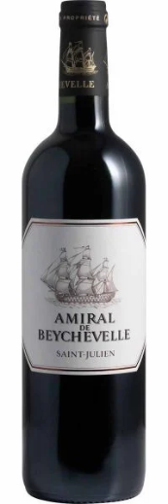
Beychevelle Amiral - $40-45. Chateau Beychevelle was 4th Growth in the famous 1855 Classification of the 60 estates making the best wine on the Left Bank.

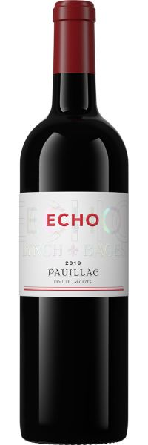
Echo de Lynch-Bages - $45-50. Chateau Lynch-Bages was a 5th Growth in the 1855 Classification.

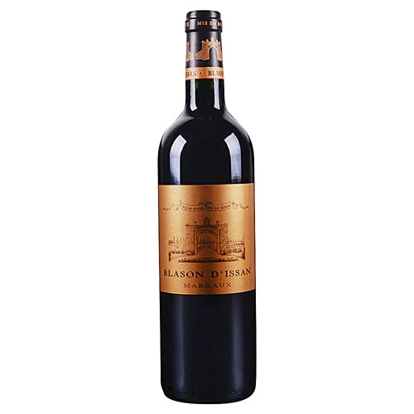
Chateau Blason d’Issan $30-35. Chateau D’Issan was a 3rd Growth in the 1855 Classification.

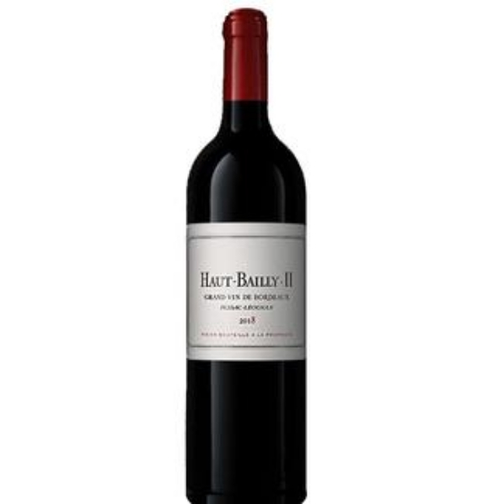
Haut Bailly HB II $35-45. Chateau Haut Bailly is a Graves Grand Cru Classe.

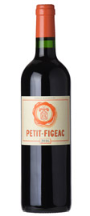
Petit Figeac $55-60. Chateau Figeac is a St. Emilion Premier Grand Cru Classe.

